**Assignment:- 1**

**Module:-** Se - Overview Of It Industry.

**1). What Is Software? What Is Software Engineering?**

**→** Software Is Basically A Set Of Instructions And Command That Tell A Computer What To Do.

→ Software Engineering: Software Engineering Is A Branch Of Computer Science That Deals With Design, Testing, And Maintenance Of Software Applications.

**2). Explain Types Of Software.**

**→** Software Types.

1. Application Software
2. System Software
3. Driver Software
4. Middleware
5. Programming Software

**3). What Is Sdlc? Explain Each Phase Of Sdlc.**

→ Sdlc: Software Development Life Cycle Is A Methodology Clearly Defined Process For Creating High Quality Software.

Phase/Steps

1. Planning
2. Analysis
3. Design
4. Implementation
5. Testing
6. Maintenance

**4). What Is Dfd? Create A Dfd Diagram On Flipkart.**

**→** A Data Flow Diagram (Dfd) Maps Out The Flow Of Information For Any Process Or System. It Uses Defined Symbols Like Rectangles, Circles And Arrows, Plus Short Text Labels, To Show Data Inputs, Outputs, Storage Points And The Routes Between Each Destination.

**5). What Is Flow Chart? Create A Flowchart To Make Addition Of Two Numbers**

**→** A Diagram That Shows The Connections Between Different Stages Of A Process Or Parts Of A System

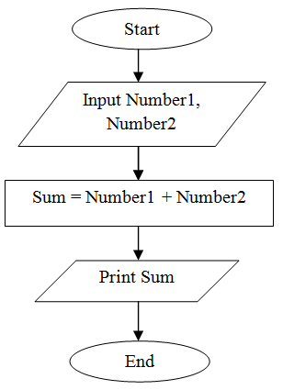

**5). What Is Use Case Diagram? Create A Use-Case On Bill Payment On Paytm.**

**→** Use-case diagrams describe the high-level functions and scope of a system. These diagrams also identify the interactions between the system and its actors.

